STRESSNET PROJECT DOCUMENTATION

Day 1

Milestone 1: System Architecture Design

- Design the end-to-end IoT + AI system architecture for monitoring structural stress in tourist bridges and viewing platforms.
- Define data flow between force, temperature, and pressure sensors, the cloud, ML model, and safety dashboard.

1. Components Overview
The StressNet system is built using a combination of sensors and a microcontroller to capture real-time structural and environmental data.
Hardware Components:
- ESP32-S3 – Main controller with built-in WiFi for data transmission
- DHT22 Sensor – Measures temperature
- BMP180 Sensor – Measures atmospheric pressure
- HX711 Module – Amplifies load cell signals
- Load Cell (5kg) – Measures force applied on the structure
- Force Sensor – Detects additional pressure variations
- LED Indicator – Displays system status
These components collectively enable real-time monitoring of structural stress parameters.

2. Platforms Used
The following platforms were used in Day 1 for simulation and data handling:
- Cirkit Designer
  - Used for designing and simulating the circuit
  - Helps visualize connections before hardware implementation
- ThingSpeak
  - Cloud platform used for storing sensor data
  - Enables real-time data visualization
  - Supports integration with IoT devices via API

3. Circuit Building
The circuit was constructed in Cirkit Designer by connecting all sensors to the ESP32-S3.
Key Connections:
- DHT22 → GPIO (Data Pin)
- BMP180 → I2C Communication (SCL, SDA pins)
- HX711 → Data (DT) and Clock (SCK) pins of ESP32
- Load Cell → HX711 Module
- Force Sensor → Analog GPIO pin
- LED → Digital GPIO pin for indication
This setup ensures proper signal flow from sensors to the microcontroller for processing.
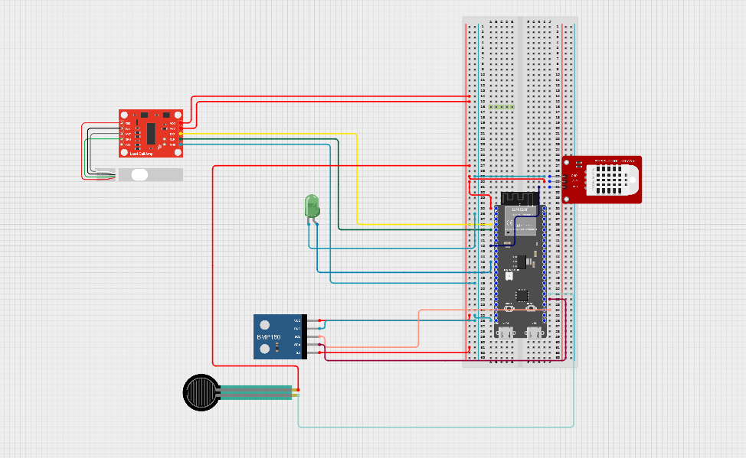

4. Flowchart Generation
A system flowchart was designed to represent the working process of StressNet.
Flow Sequence:
- Sensor data collection
- Signal processing by ESP32
- Data transmission via WiFi
- Upload to ThingSpeak cloud
- Data visualization
The flowchart helps in understanding the system logic and data pipeline clearly.
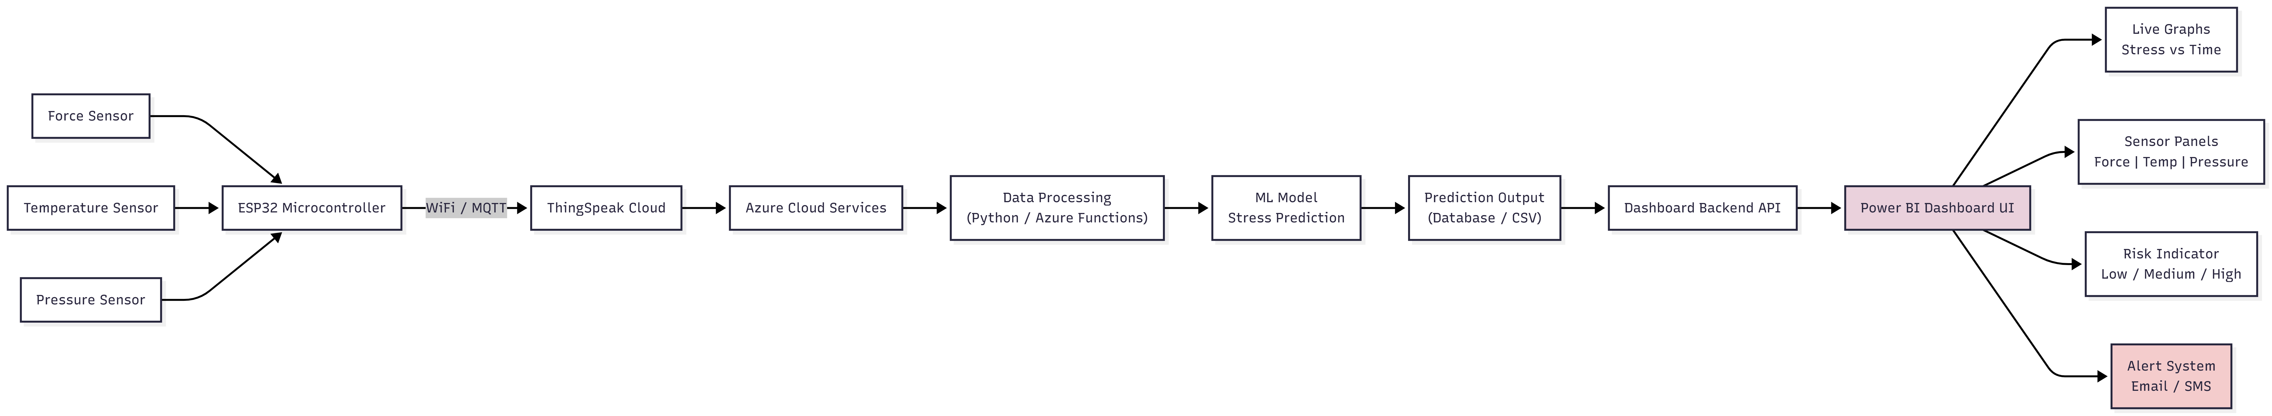

5. Live Data Generation using ThingSpeak
Real-time data transmission was established using ThingSpeak.
Process:
- ESP32 connects to WiFi
- Sensor readings are collected periodically
- Data is sent to ThingSpeak using API keys
- Values are updated in real-time graphs
Outcome:
- Continuous monitoring of force, temperature, and pressure
- Real-time visualization through ThingSpeak dashboard
- Initial dataset generated for further analysis
OUTPUT:
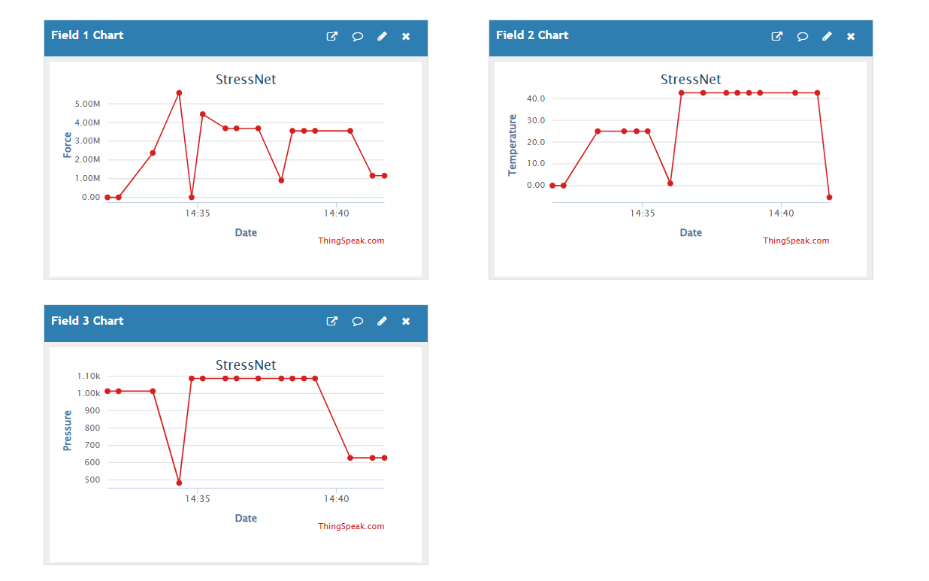



Consolidated Outcome of Day 1
By the end of Day 1, the foundational setup of the StressNet system was successfully established. All required hardware components were identified and virtually integrated using Cirkit Designer, ensuring correct circuit connections and system feasibility.
A functional circuit design was completed, connecting sensors such as the load cell (via HX711), DHT22, BMP180, and force sensor to the ESP32-S3 microcontroller. The overall system workflow was clearly defined through a flowchart, outlining the process from data acquisition to cloud storage.
Additionally, real-time data transmission was achieved using ThingSpeak. The ESP32 successfully sent live sensor readings to the cloud platform, where data could be visualized in the form of graphs. This confirmed that the system is capable of continuous monitoring and data logging.
Overall, Day 1 resulted in a working IoT pipeline that captures, processes, and uploads live environmental and structural data, forming a strong base for further development such as data analysis and machine learning integration, which helped us to achieve milestone 1.

